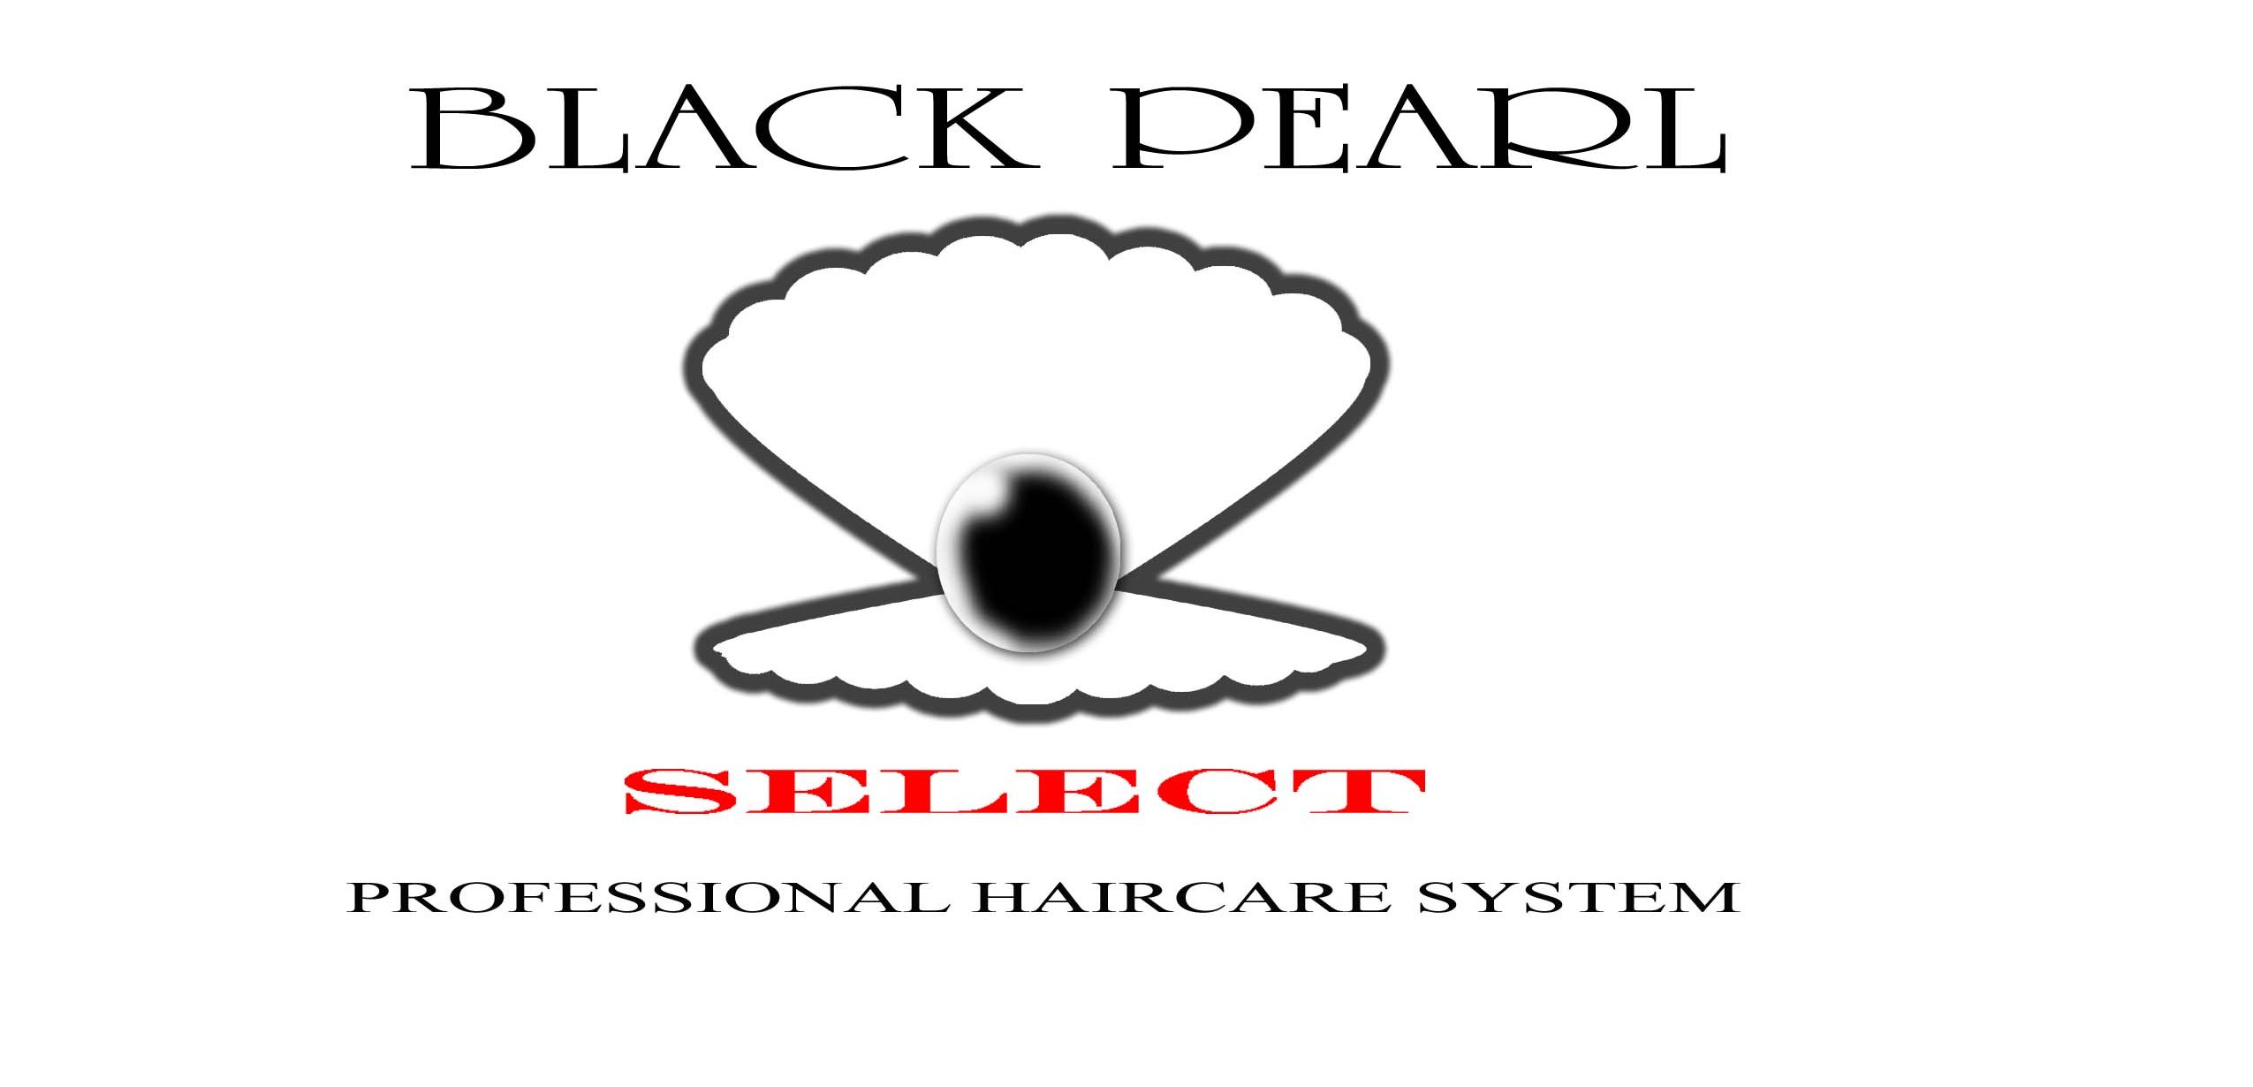
COMEDY LUAU VENDOR APPLICATION FORM

General vendors, local and non-local, are invited to set up booths to display or sell approved products from their business. Food vendors may display/advertise but are not allowed to sell during the luau.

Vendor Display Booths are available for $50.

Vendor Selling Booths are available for $100. Restricted items include water, food, soda, various sweets & candies, sauces or luau shirts. If your product is among these items, please consider setting up a Display/Advertisement Booth only.

Provide own tables and chairs. Tents are allowed if desired.

Please arrive in time to be set-up by 10am.
EVENT DATE IS SATURDAY, JULY 8, 2009
PLEASE PRINT AND RETURN WITH VENDOR FEE
(Deadline is Wednesday, July 8, 2009 postmarked)

Business Name _________________________________________________

Product(s)______________________________________________________

Address_______________________________________________________

Phone_________________________________________________________

Email_________________________________________________________

Amount enclosed $_____________

Make Check/Money Order Payable to: Black Pearl Select – Comedy Luau 2009

Complete this portion and mail to:
Black Pearl Select Salons
2908 Meridian Street, Suite A
Huntsville, AL 35811

An email confirmation will be sent upon receipt

